WEB TECHNOLOGY WITH UI UX

ASSIGNMENT 1 – TASK 1

NAME: KALARIYA KHUSHI ROLLNO: 53

CLASS: 4CEC BRANCH: CE

Step 1 - Click on New button to create a new repository

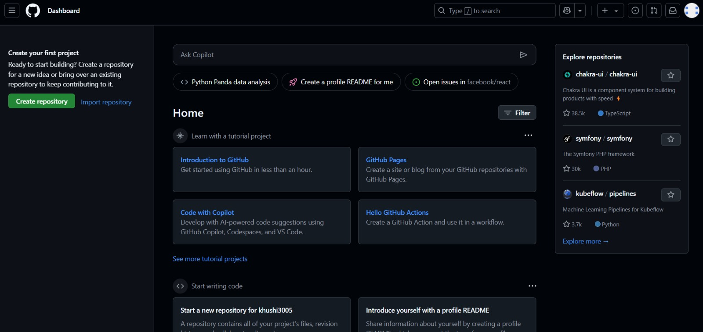

Step 2 - In the Repository name field, enter your enrollment number

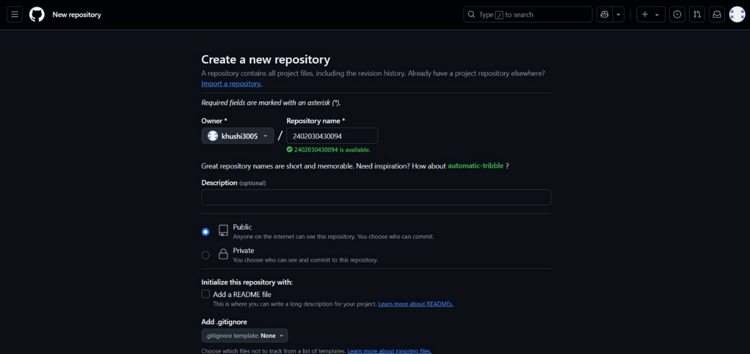

Step 3 - Click "Create repository".

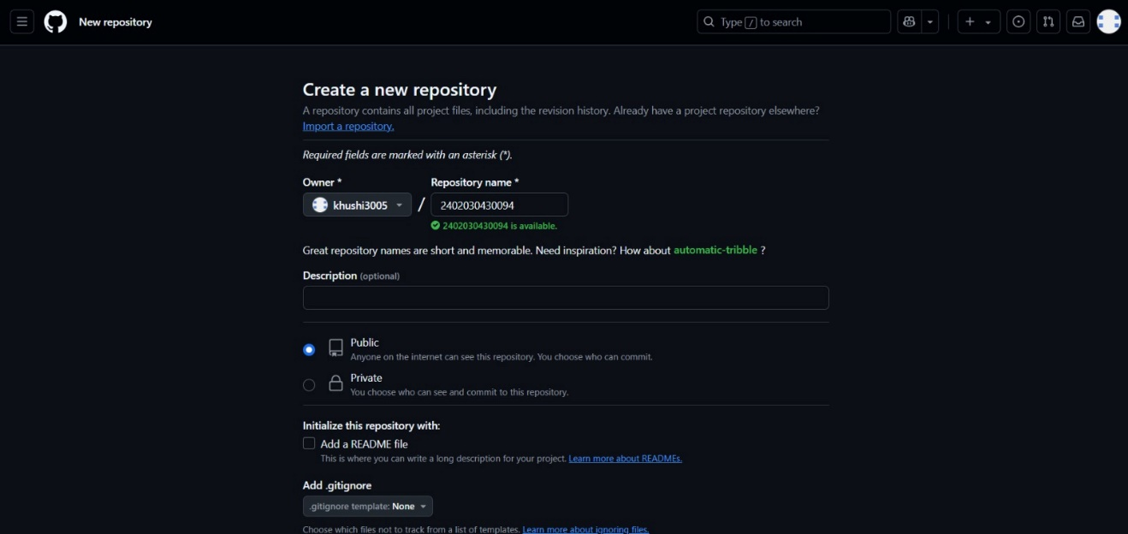

Step 4 - Click the "Add file" dropdown, select "Create new file

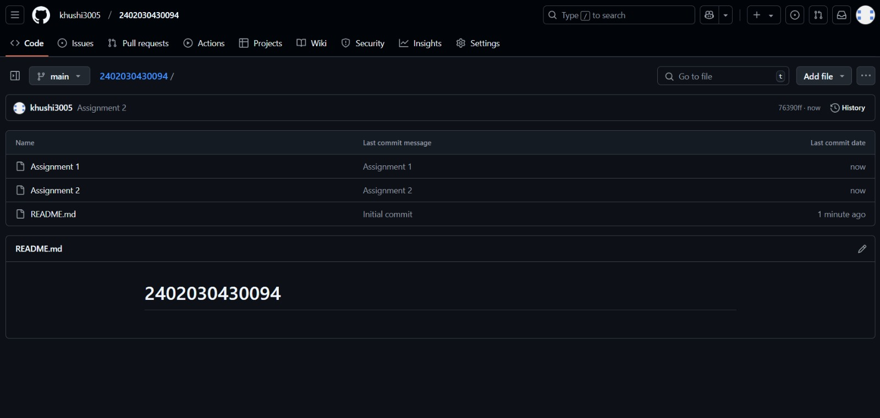

Step 5 – Assignment 1 folder created

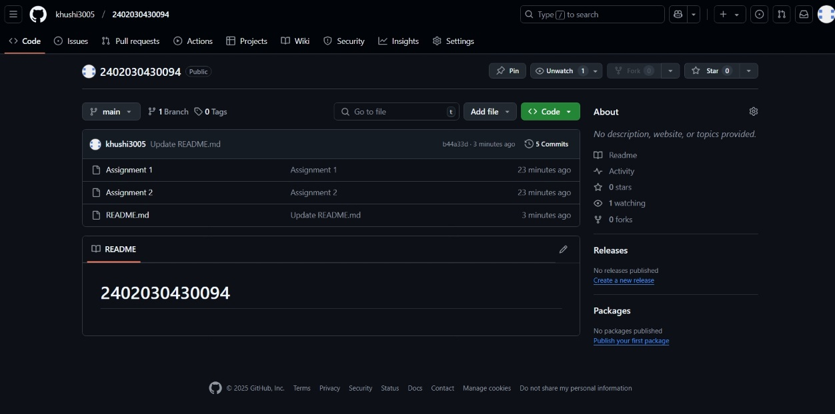

Step 6 – Add the file into the assignment 1 folder

